**Homework 1 – Magnetic Circuits and Inductors**

**Q.1. Inductor Design:**

A grid connected photovoltaic system is usually composed of solar panels, a DC/DC converter, a three phase inverter (which is a DC/AC converter) and an LCL type filter for grid connection, as shown in Figure 1. The aim of LCL filter is to eliminate the harmonic distortion created by the inverter.

In this question, you are asked to design one of the inductors (L1) of this filter and the following specifications are given below. The picture of inverter with LCL filter and the picture of the core are shown in Figure 2.

**Inductance:** 220 µH

**Core type and material:** Toroid, ferrite (77 material)

**Core dimensions:**

* Effective Magnetic Path Length: 145 mm
* Effective Cross Section Area: 15.8 mm²

**Saturation flux density of the core:** 0.51 Tesla

**Core B-H characteristics:** Given in the attached file: *B-H_data.xlsx*



Figure 1: A grid-connected photovoltaic system

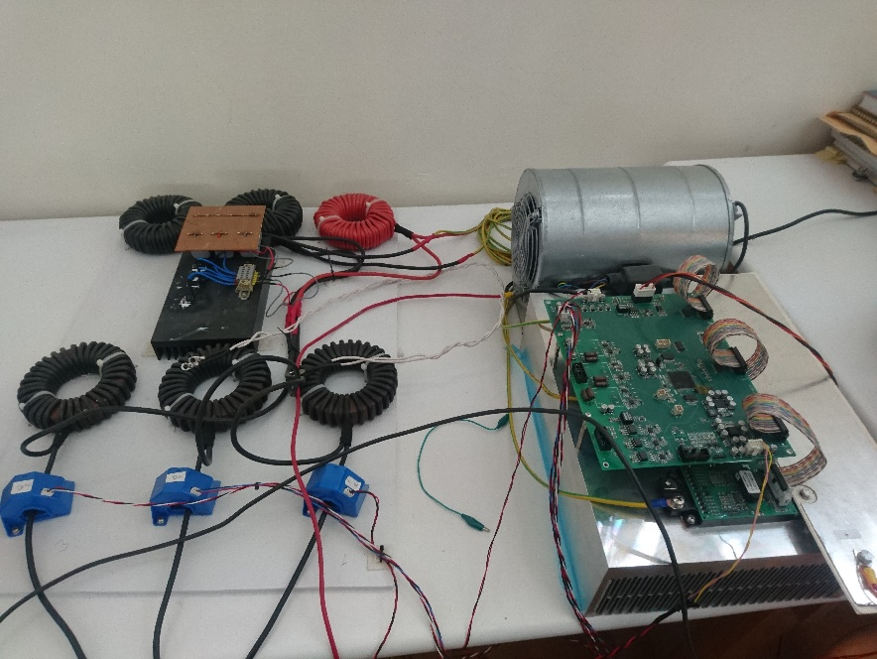 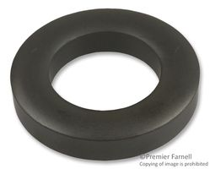

Figure 2: The picture of inverter with LCL filter and the picture of the core

[*http://www.fair-rite.com/77-material-data-sheet*](http://www.fair-rite.com/77-material-data-sheet)

1. In this part, you will consider two cases:
   * The core is linear with ***relative permeability of 3000*** up to its saturation point.
   * The core has the nonlinear B-H characteristics as in the attached file.
2. Calculate the required number of turns for an inductance of 220 µH assuming the relative permeability of the core is 3000.
3. Sketch the B-H characteristics of the core for both cases, on the same figure.
4. Find the current of the inductor in order to create a flux density of 0.30 Tesla for both cases.
5. Repeat C with 0.45 Tesla. Comment on the results.
6. Find the maximum current that this inductor can carry without saturating the core, using the linear B-H curve. Assume the number of turns is kept constant at the value found in part I.
7. Find the stored energy with the current value found in II. Also verify your calculation by using the operating B-H (linear) point and core volume. Comment on the result.
8. Propose a method to increase the stored energy on this inductor without changing the dimensions of the core. With you solution, will the required number of turns change to achieve the same inductance? If yes, how? Explain.
9. Assuming the number of turns is kept constant, compare the values of the following parameters if the inductor operates in the linear region and in the saturation region.

* Relative permeability
* Reluctance
* Inductance

You do not need to give a numerical answer, but you need to give reasoning.

**Q.2.** Consider the magnetic circuit given in Figure 3. Assume that the core is linear up to its saturation point. The core saturates at 1.0 Tesla as shown in Figure 3. N is 30 turns. The cross-sectional area of the core is 10 cm2 everywhere. Neglect leakage and fringing flux.

**Hint:** You do not have to show, but drawing a magnetic equivalent circuit in a paper will help you a lot in this question.



Figure 3: The magnetic circuit and its linear B-H characteristics with saturation

1. Calculate the relative permeability of the core in its linear portion.
2. Calculate the coil-A current to get the flux density of 0.9 Tesla in leg-B, when coil-B is open circuited.
3. With the coil current in part A, calculate the flux density in the air gap.
4. Find the flux densities in leg-B and in the air gap when both coils are excited with the same amount of current in the given directions.
5. Suppose that the current in part A is doubled when coil-B is open circuited. What will be flux densities in the air gap and leg B?
6. Assume that a resistor is connected to coil-B, when the coil-A is ***excited with direct current***. Is it possible to dissipate power on the resistor? Why or why not? Comment.
7. Assume that a ***sinusoidal excitation is applied*** to coil-A such that the peak flux density in the air gap is 0.9 Tesla. Suppose also that a resistor is connected to the coil-B. Is it possible to dissipate power on the resistor this time? Why or why not? Comment.
8. Assume now that the excitation current in part VII is doubled. Will the current on the resistor increase proportionally? Why or why not? Comment.
9. Assume that the gap is removed (g = 0). In this case, does the mutual inductance between the two coils increase or decrease compared with the initial geometry? Comment.